***Dt : 29/8/2022***

***1.Constructors without parameters:***

***=>The Constructors which are declared without parameters are***

***known as 0-parameter Constructors or Constructors without***

***parameters.***

***Ex-Program : DemoCon1.java***

***class CTest1 //SubClass***

***{***

***int a=10;***

***CTest1()//Constructor***

***{***

***System.out.println("====Constructor====");***

***System.out.println("The value a:"+a);***

***}***

***void dis()//Instance methods***

***{***

***System.out.println("====Instance dis()=====");***

***System.out.println("The value a:"+a);***

***}***

***}***

***class DemoCon1 //MainClass***

***{***

***public static void main(String[] args)***

***{***

***CTest1 ob = new CTest1(); //Con_Call***

***ob.dis(); //method_call***

***ob.dis();***

***ob.dis();***

***}***

***}***

***====Constructor====***

***The value a:10***

***====Instance dis()=====***

***The value a:10***

***Execution flow of above program:***

***ClassFiles:***

***CTest1.class***

***DemoCon1.class(MainClass)***

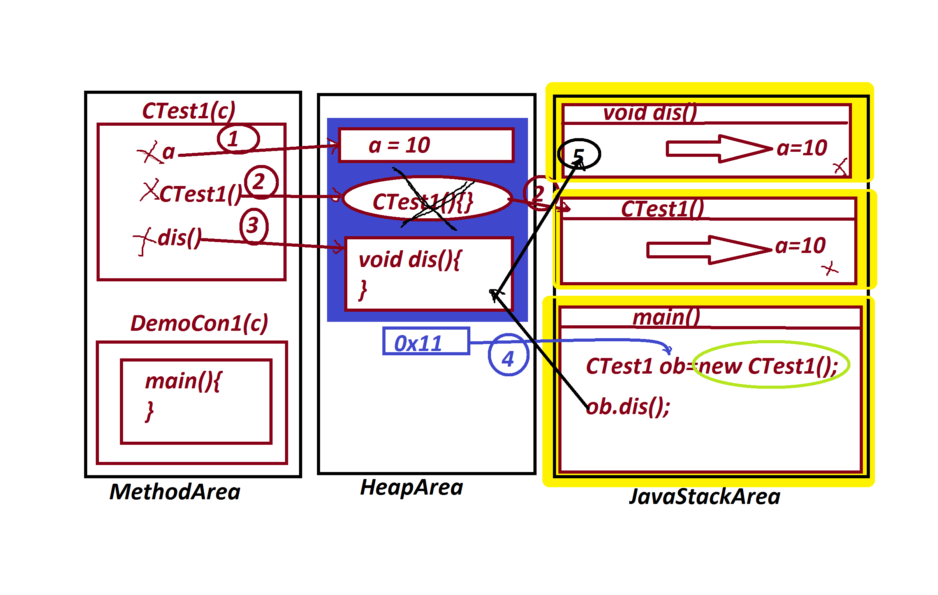

***============================================================***

***faq:***

***wt is the diff b/w***

***(i)Constructor***

***(ii)Instance method***

***=>Constructor is executed while object creation,but Instance***

***method is executed after Object creation.***

***=>Constructor is executed only once while object creation process,***

***but Instance methods are executed any number of times from the***

***same object.***

***faq:***

***define destructors in Java?***

***=>There is no concept of destructors in Java,becuase the***

***constructors are destroyed automatically after execution.***

***=========================================================***

***2.Constructors with parameters:***

***=>The constructors which are declared with parameters are***

***known as Parameterized Constructors or Constructors with***

***parameters.***

***Ex-program : DemoCon2.java***

***class CTest2 //SubClass***

***{***

***CTest2(int x)//Constructor***

***{***

***System.out.println("====Constructor CTest2(x)====");***

***System.out.println("The value x:"+x);***

***}***

***void dis(int y)//Instance method***

***{***

***System.out.println("====Instance dis(y)=====");***

***System.out.println("The value y:"+y);***

***}***

***}***

***class DemoCon2 //MainClass***

***{***

***public static void main(String[] args)***

***{***

***CTest2 ob = new CTest2(122); //Con_Call***

***ob.dis(125); //method_call***

***}***

***}***

***o/p:***

***====Constructor CTest2(x)====***

***The value x:122***

***====Instance dis(y)=====***

***The value y:125***

***======================================================***

***Note:***

***=>we pass parameters to the constructor while object creation***

***process,because the constructor call is available in Object***

***creation syntax.***

***==========================================================***

***Advantage of Constructors:***

***=>Constructors are used to initialize instance variables while***

***object creation process,and which saves the execution time and***

***generate HighPerformance of an application.***

***============================================================***

***Ex-Program : DemoCon3.java***

***import java.util.Scanner;***

***class Customer //SubClass***

***{***

***//Instance Variables memory in Object***

***String cId,cName,cMailId,city;***

***long cPhNo;***

***//Variables in Constructor are Local Variables memory in method***

***Customer(String cId,String cName,String cMailId,***

***long cPhNo,String city)//Con_with_parameters***

***{***

***this.cId = cId;***

***this.cName = cName;***

***this.cMailId = cMailId;***

***this.cPhNo = cPhNo;***

***this.city = city;***

***}***

***void getCustomer()***

***{***

***System.out.println("====CustomerDetails====");***

***System.out.println("CustId:"+cId);***

***System.out.println("CustName:"+cName);***

***System.out.println("CustMailId:"+cMailId);***

***System.out.println("CustPhNo:"+cPhNo);***

***System.out.println("CustCity:"+city);***

***}***

***}***

***class DemoCon3 //MainClass***

***{***

***public static void main(String[] args)***

***{***

***Scanner s = new Scanner(System.in);***

***//Local Variables in main() method***

***System.out.println("Enter the CustId:");***

***String cId = s.nextLine();***

***System.out.println("Enter the CustName:");***

***String cName = s.nextLine();***

***System.out.println("Enter the CustMailId:");***

***String cMailId = s.nextLine();***

***System.out.println("Enter the CustPhNo:");***

***long cPhNo = Long.parseLong(s.nextLine());***

***System.out.println("Enter the CustCity:");***

***String city = s.nextLine();***

***Customer c = new Customer(cId,cName,cMailId,cPhNo,city);//ConClass***

***c.getCustomer();***

***}***

***}***

***o/p:***

***Enter the CustId:***

***A111***

***Enter the CustName:***

***Raj***

***Enter the CustMailId:***

***raj@gmail.com***

***Enter the CustPhNo:***

***9898981234***

***Enter the CustCity:***

***Hyd***

***====CustomerDetails====***

***CustId:A111***

***CustName:Raj***

***CustMailId:raj@gmail.com***

***CustPhNo:9898981234***

***CustCity:Hyd***

***===============================================***